- Login Page (US001)

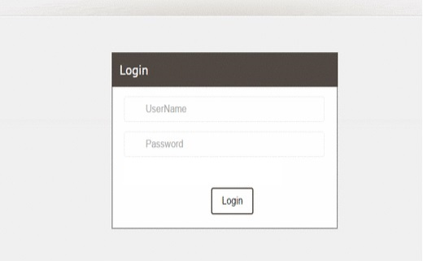
FIG 1
- Create Customer (US002)

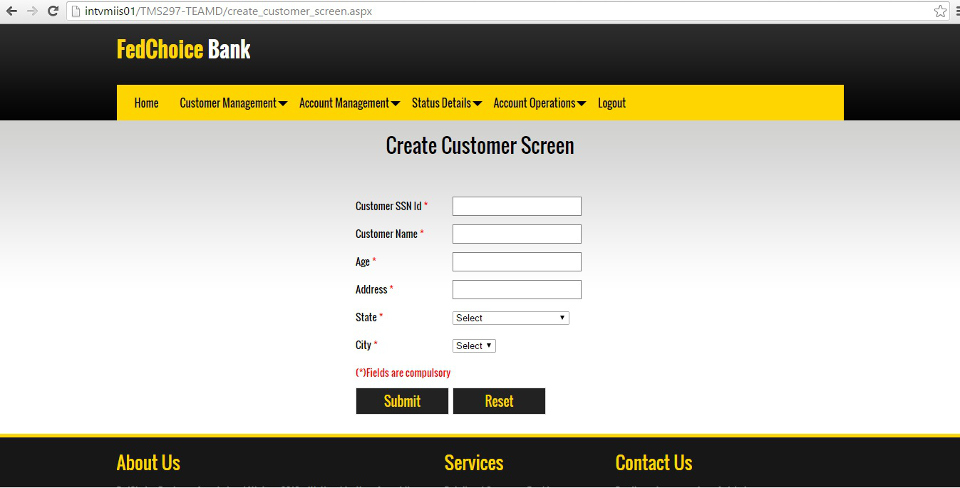
FIG 2

- Update Customer (US003)

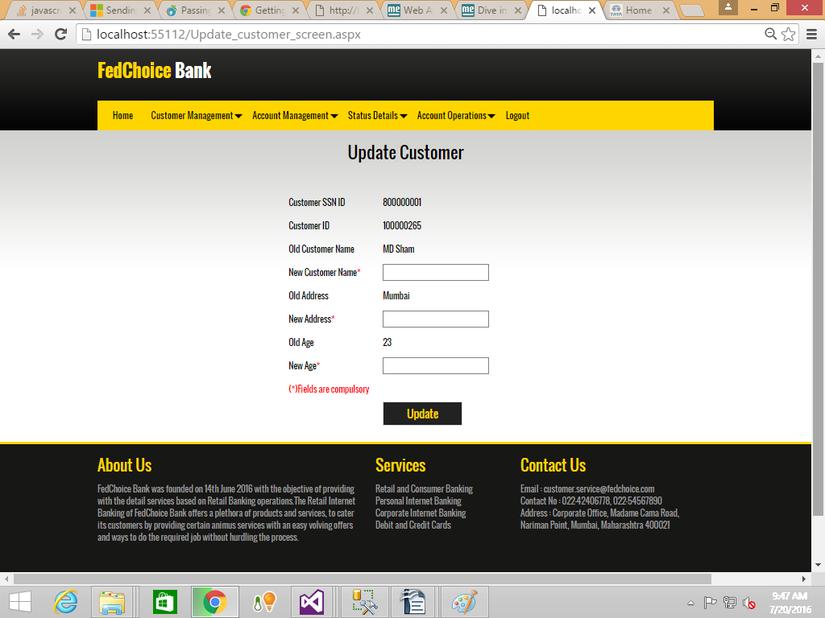
FIG 3

- Delete Customer (US004)

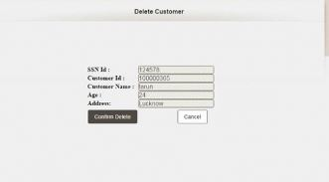

FIG 4

- Customer Status (US005)

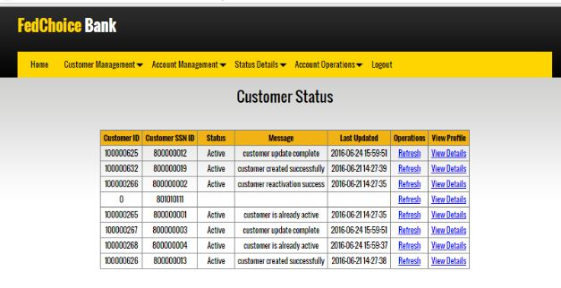
FIG 5

- Create Account (US006)

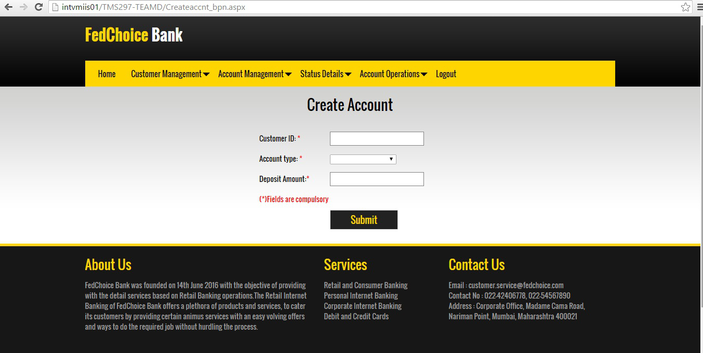

FIG 6

- Delete Account (US007)

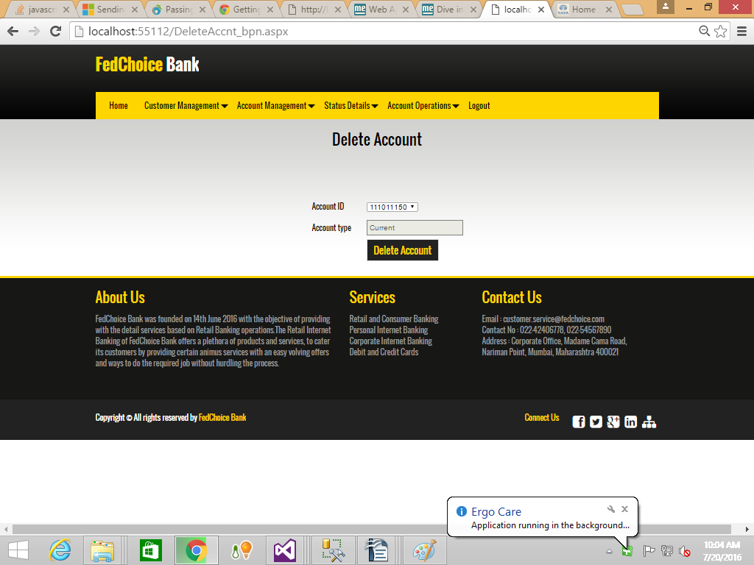
FIG 7

- Account Status (US008)

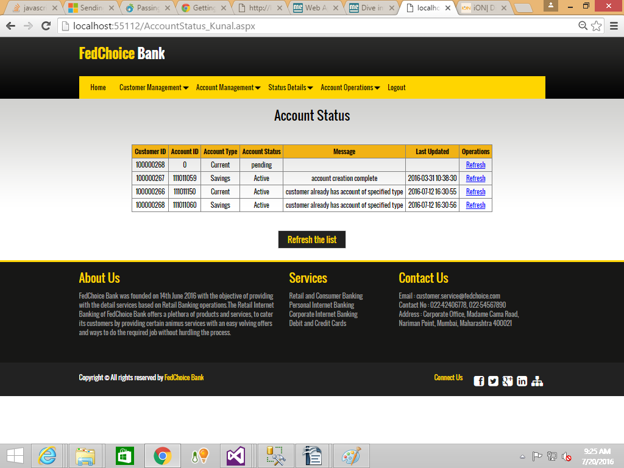
FIG 8

- Customer-Search (US009)

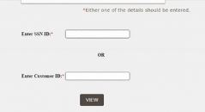
FIG 9

- Account Search (US010)

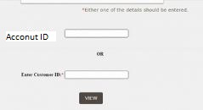
FIG 10

- Deposit Money (US011)

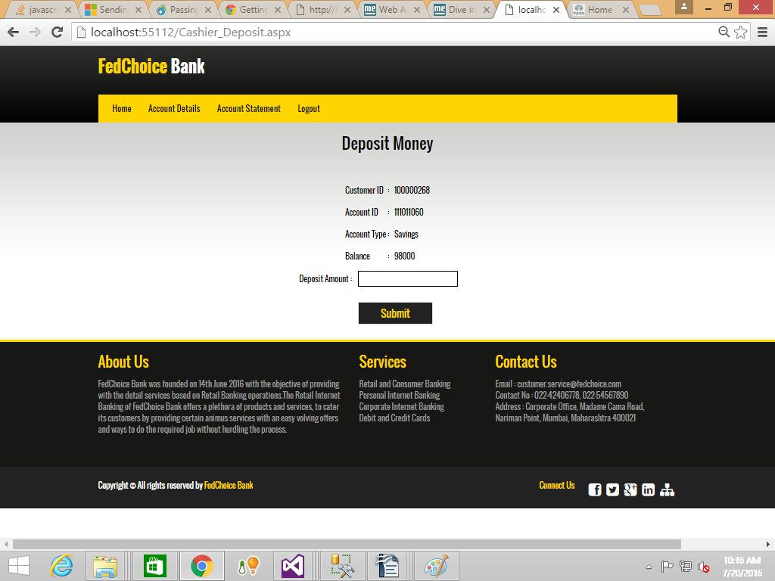

FIG 11

- Withdraw Money (US012)

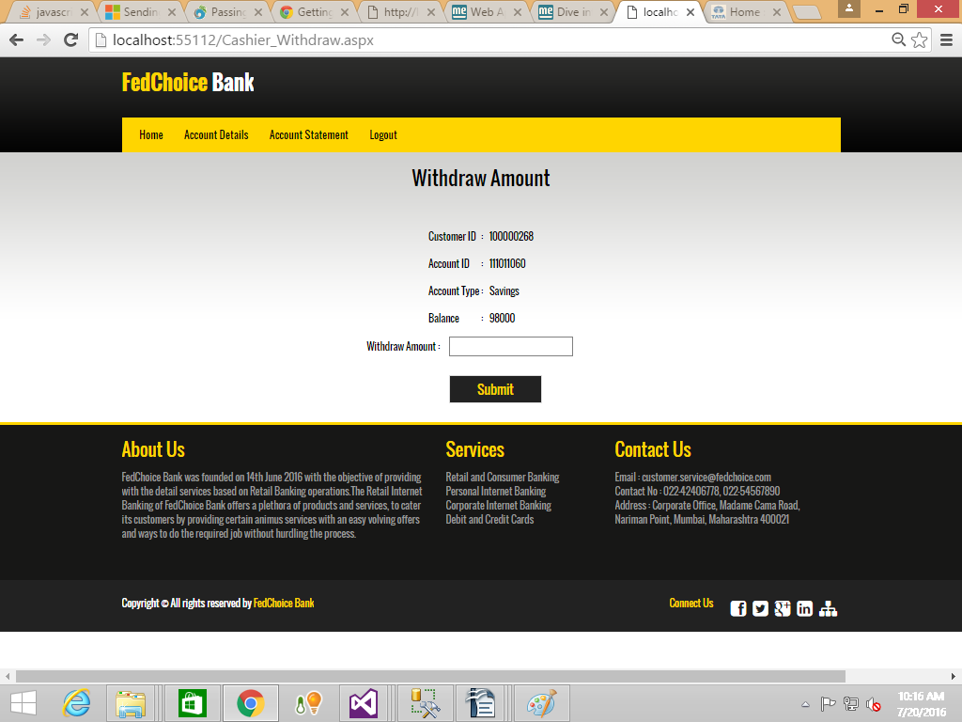
FIG 12

- Transfer Money (US013)

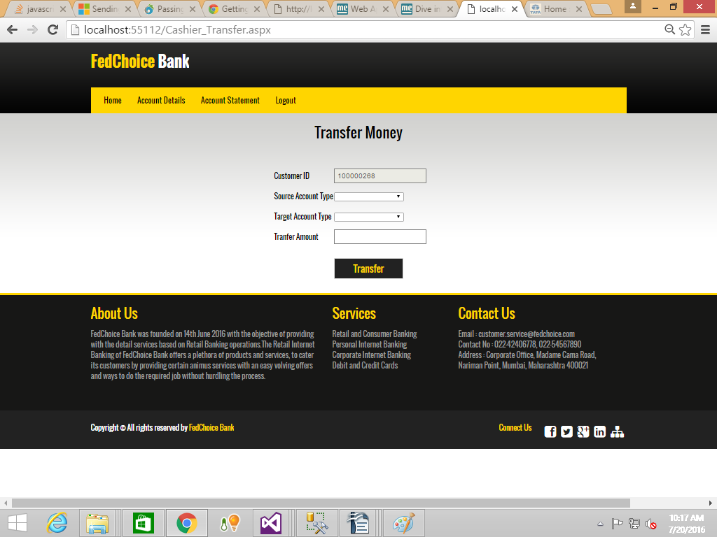
FIG 13

- View/Print Statements (US014)

A. View Statement by No of transaction
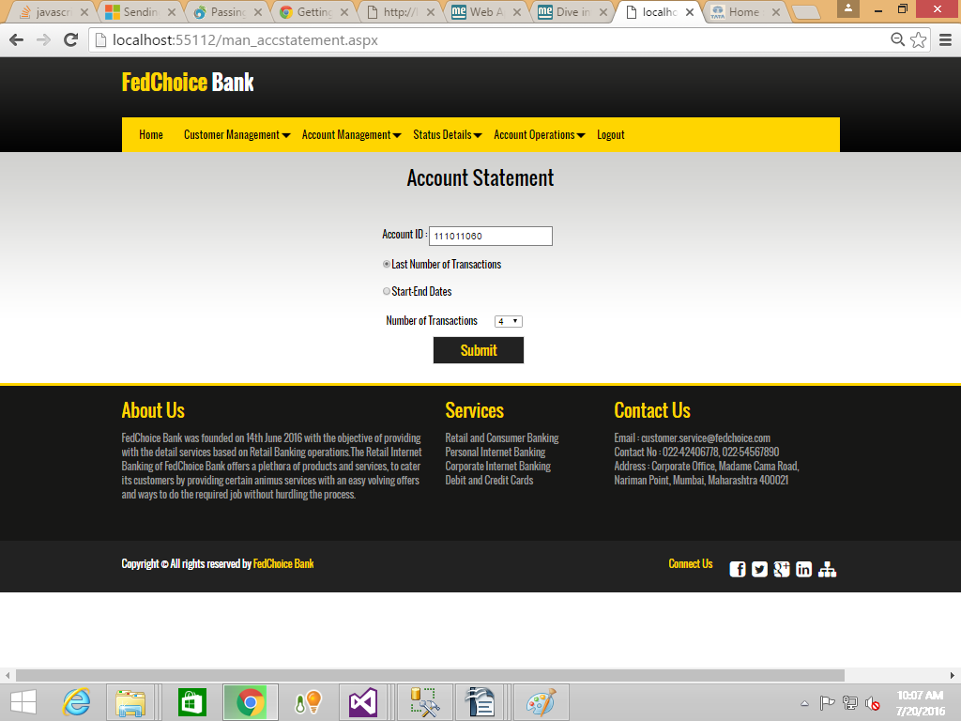
FIG 14.1

B. View Statements by Start and End Date.

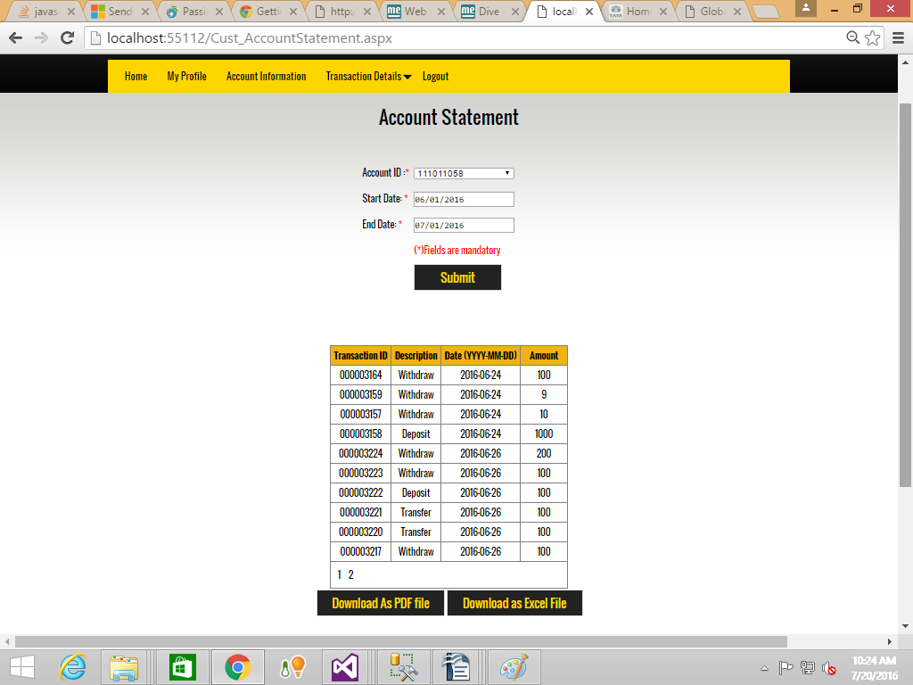
FIG 14.2

